Copyright for test papers and marking guides remains with *West Australian Test Papers.*

Test papers may only be reproduced within the purchasing school according to the advertised Conditions of Sale.

Test papers should be withdrawn after use and stored securely in the school until 14th October 2019.



**SEMESTER TWO**

**MATHEMATICS**

**SPECIALIST**

**UNITS 3 & 4**

**2019**

**SOLUTIONS**

**Calculator−Free Solutions**

1. ✓✓

i.e.

i.e. the complex number lies on the line ✓

✓✓ [5]

2. (a)

✓

✓✓

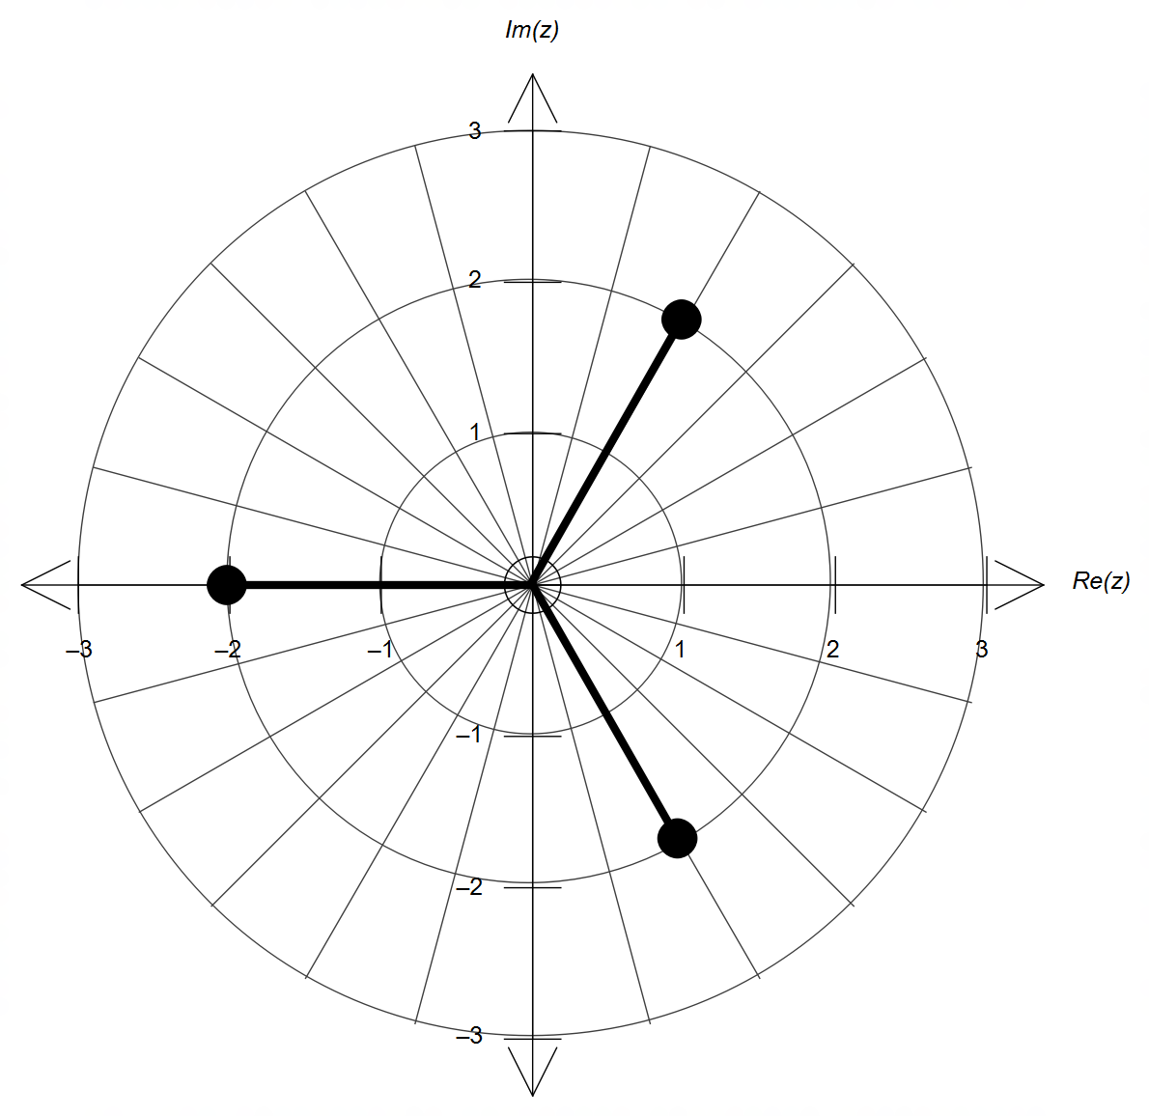

(b)

✓ magnitude = 2

✓ radians apart

(c)

expanding with gives:

and therefore and ✓

(division of polynomials is also possible)

Hence, ✓

(d) ✓

✓✓ [10]

3. (a) ✓

✓

✓

(b) Using the substitution recommended in (a):

✓✓ [4]

(other method is possible by setting )

4. (a) provided ✓

✓

✓✓

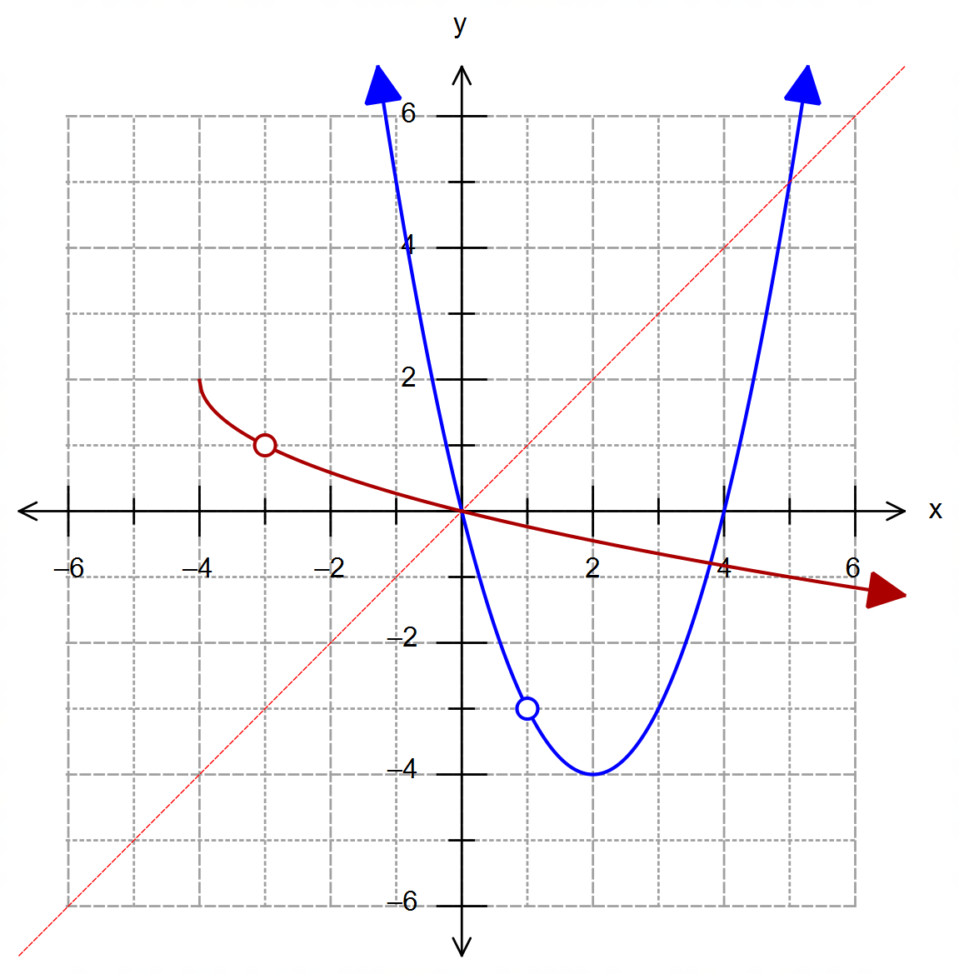

(b)

(b)

✓ parabola with roots at x=0 and 4, with tp at (2,-4)

✓ discontinuity at (1,-3)

(d)

✓ square root function

with tp at (-4,2)

✓ discontinuity at (-3,1)

4. (c) Turning point at ✓

Algebraically by rearranging to make the subject

gives ✓

(d) Shown on the graph in (b). ✓✓ [10]

5. (a) ✓

(b) The line can be obtained from two points, by choosing

any two different values of .

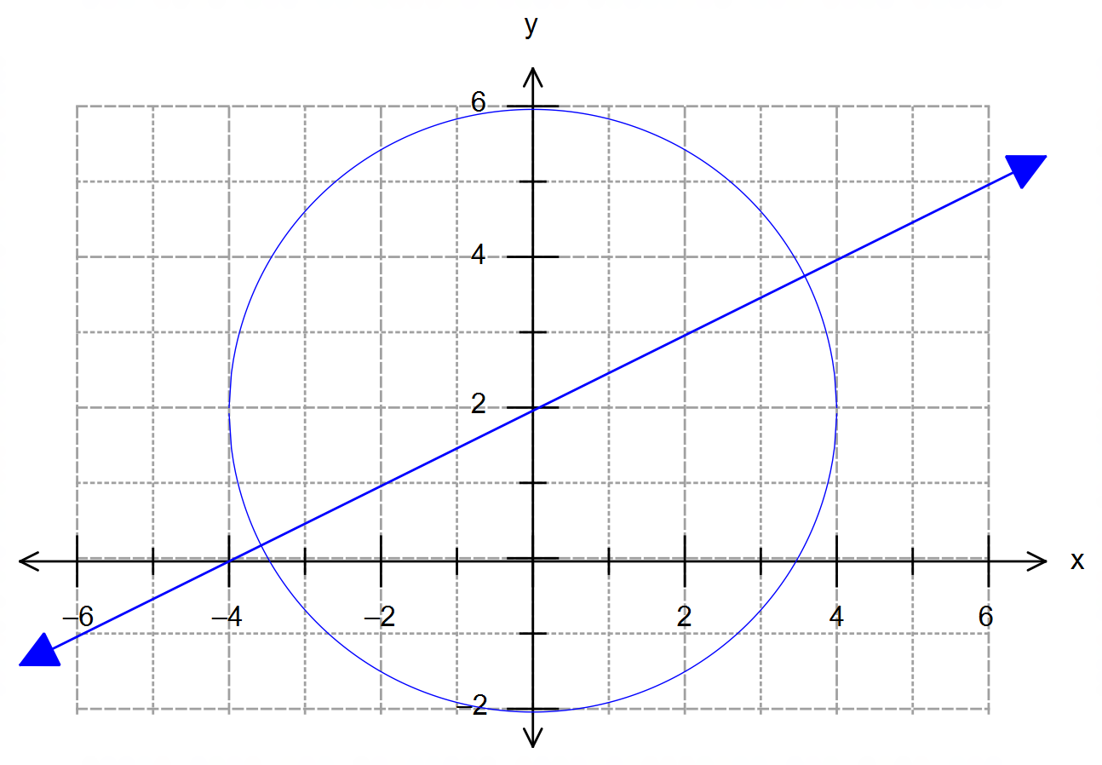

✓✓ line

✓

✓

✓ [6]

6. (a) Choosing the polar point :

✓

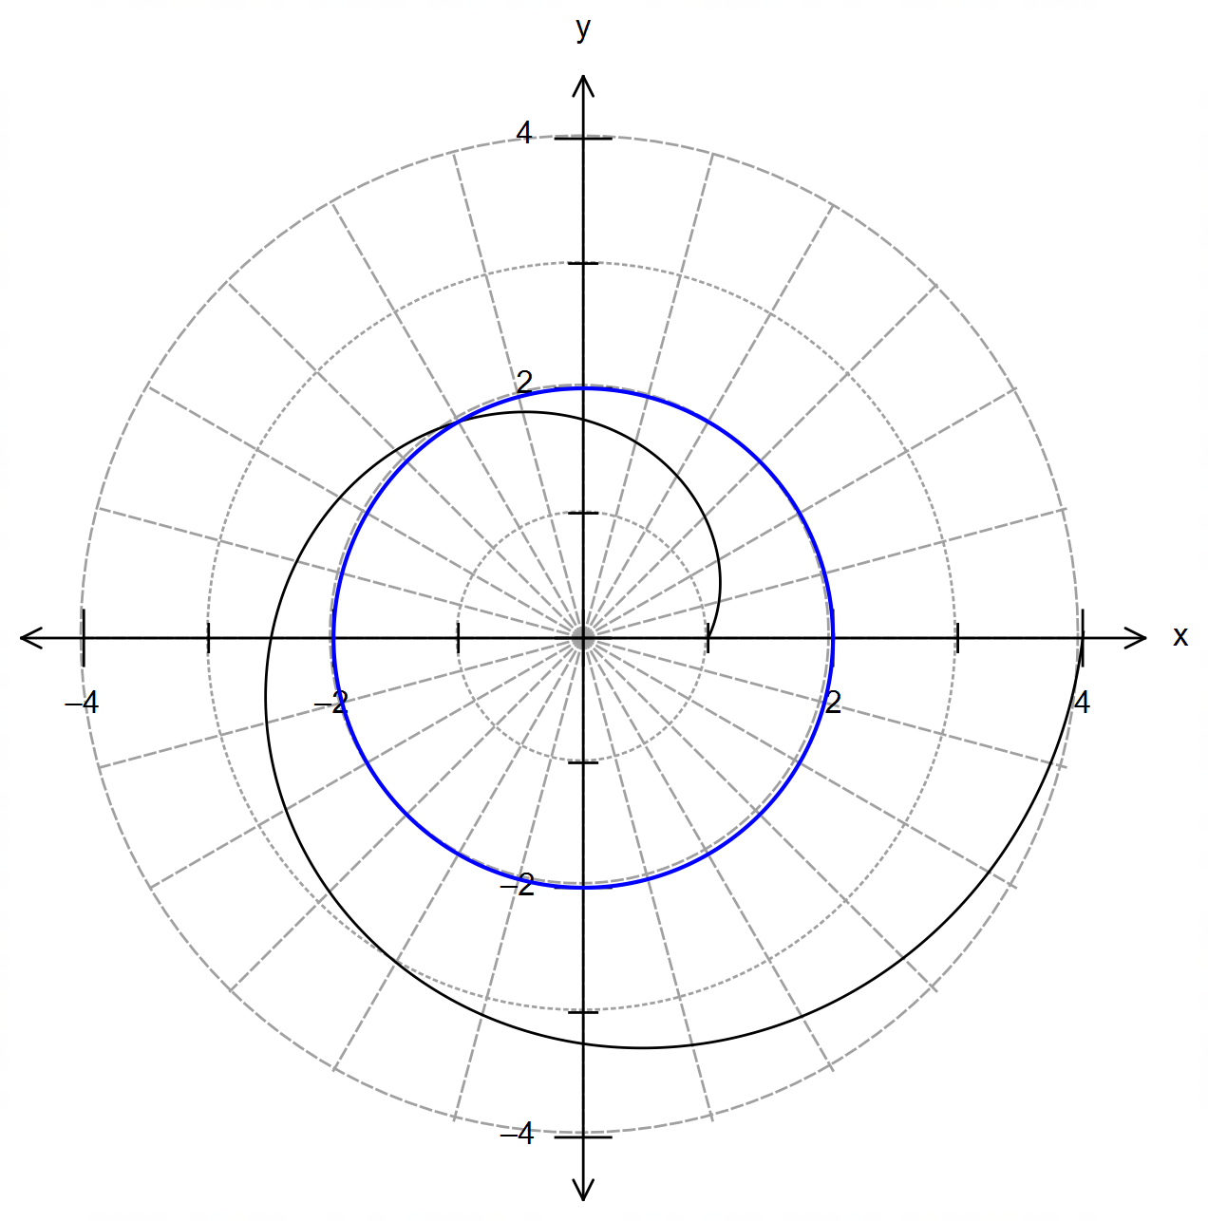 (b)

✓ circle cented at O

with radius 2

(c) Using :

✓✓

✓✓ [6]

7. (a) Area of a segment:

✓

(b) ✓

(c) ✓

✓

✓

(d)

✓

when m we obtain ✓

✓ [8]

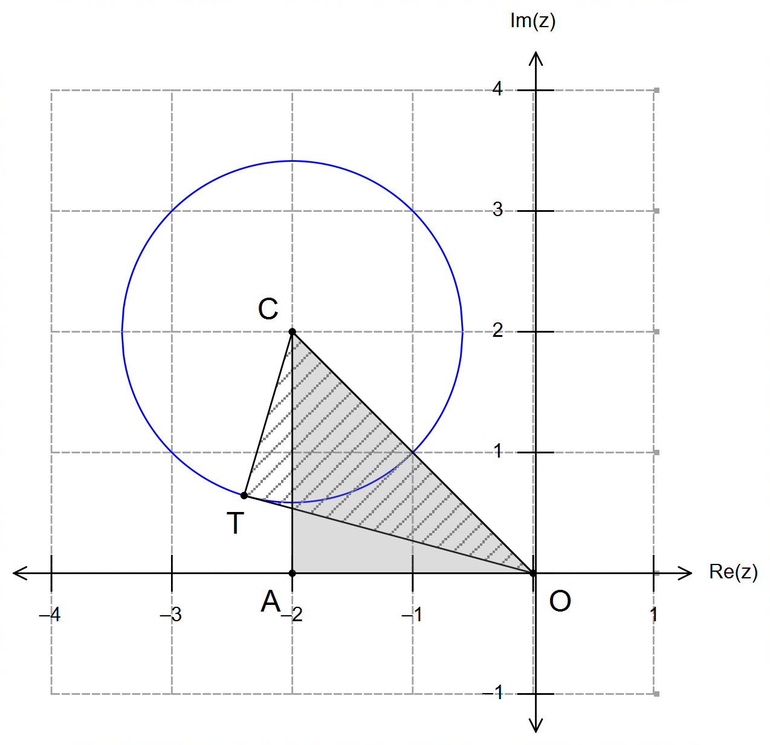**Calculator−assumed Solutions**

8. From the diagram we obtain two

right angled triangles:

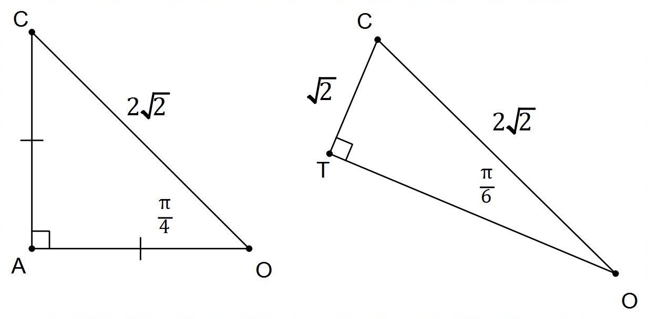

And therefore we have:

✓

✓

✓✓

✓ [5]

9. (a) ✓

✓

(2dp.) ✓

(b)

✓ Normal distribution

centred at

✓ Indicates a standard

deviation of approx. 3 min

✓ Refers to (a) with area

shaded

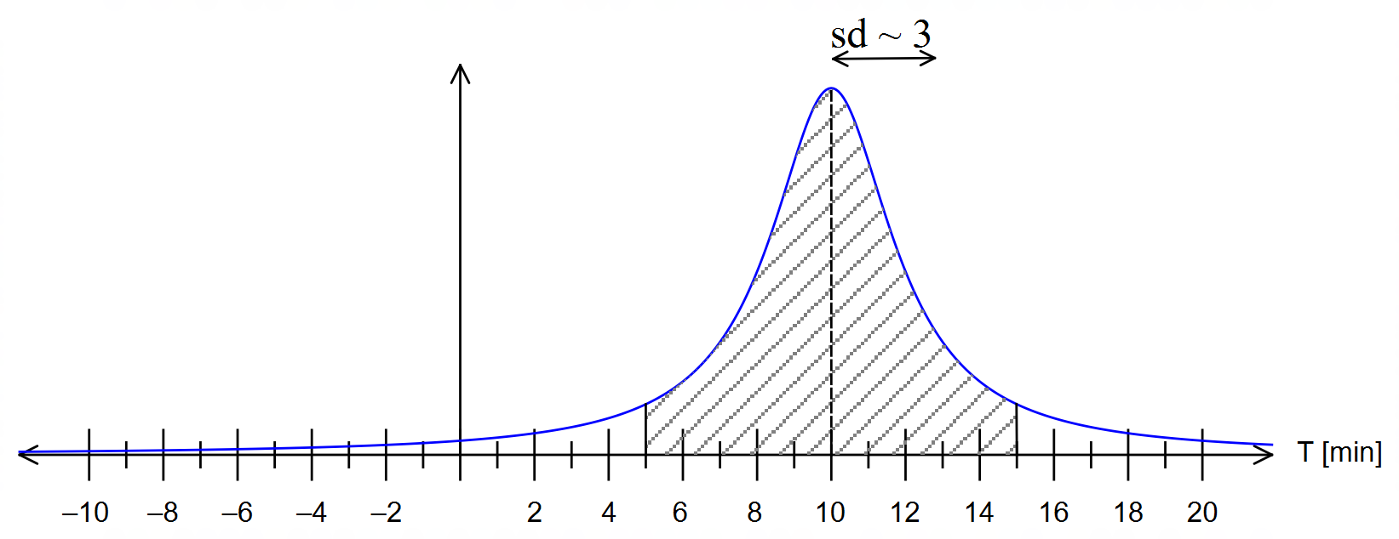

[6]

10. (a)

✓✓✓

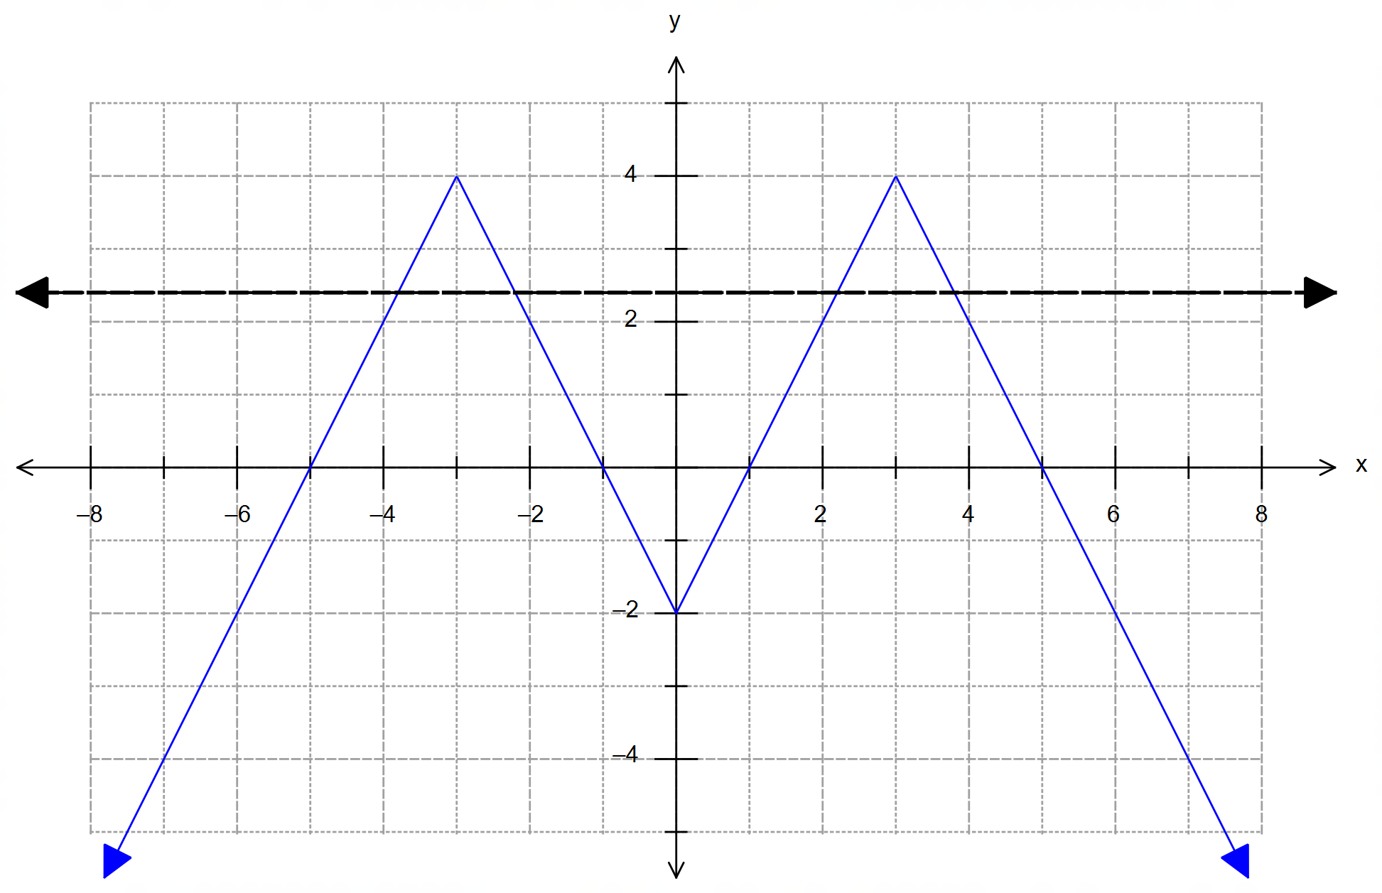 (b) The diagram below shows :

Thefore, a horizontal line would intersect the graph

for . ✓✓✓ [6]

(graphical explanation can be accepted)

11. (a) location of ground collision ✓

seconds ✓

✓

and from O ✓

(b) point 10 km above ground

sec from detection time ✓

✓

displacement vector for ABM ✓

✓

11. (c) (Using the conditions for collision will show that they do

not collide. If no other work is shown then award two marks for this attempt)

Using closest-approach method with CAS: fmin

and

✓✓

✓

CAS:fmin for ✓✓ [13]

12. (a) ✓✓

(b) The slope is undefined at ✓

(c)

✓

✓

✓ [7]

13. (a) is approximately normally distributed as the sample

size

✓✓

i.e. ✓

(b) ✓✓

(c) No, there is no change. ✓

Because the sample size provides a normal

distribution for the sample means, despite the shape

of the parent distribution. ✓

13. (d) ✓

and , i.e.

If ✓

✓✓ [11]

14. (a) (i) ✓

(ii)

✓

✓

(b)

Let

then:

for ✓

for ✓

✓

[8]

15. (a)

✓

✓

15. (b) ✓

✓

Since exponential decay never crosses the x-axis, we must

choose the first value that would round to zero.

i.e. (other values less than 100.5 are acceptable)

✓

✓ [7]

16. (a) from formula sheet ✓

(b) from formula sheet, with 5000 as limit ✓✓

and

solving simultaneously: CAS ✓✓

(c) Since the line is the upper asymptote, it will never

actually reach 5000. Therefore we must choose the first value

that would round to 5000:

✓

CAS ✓ [7]

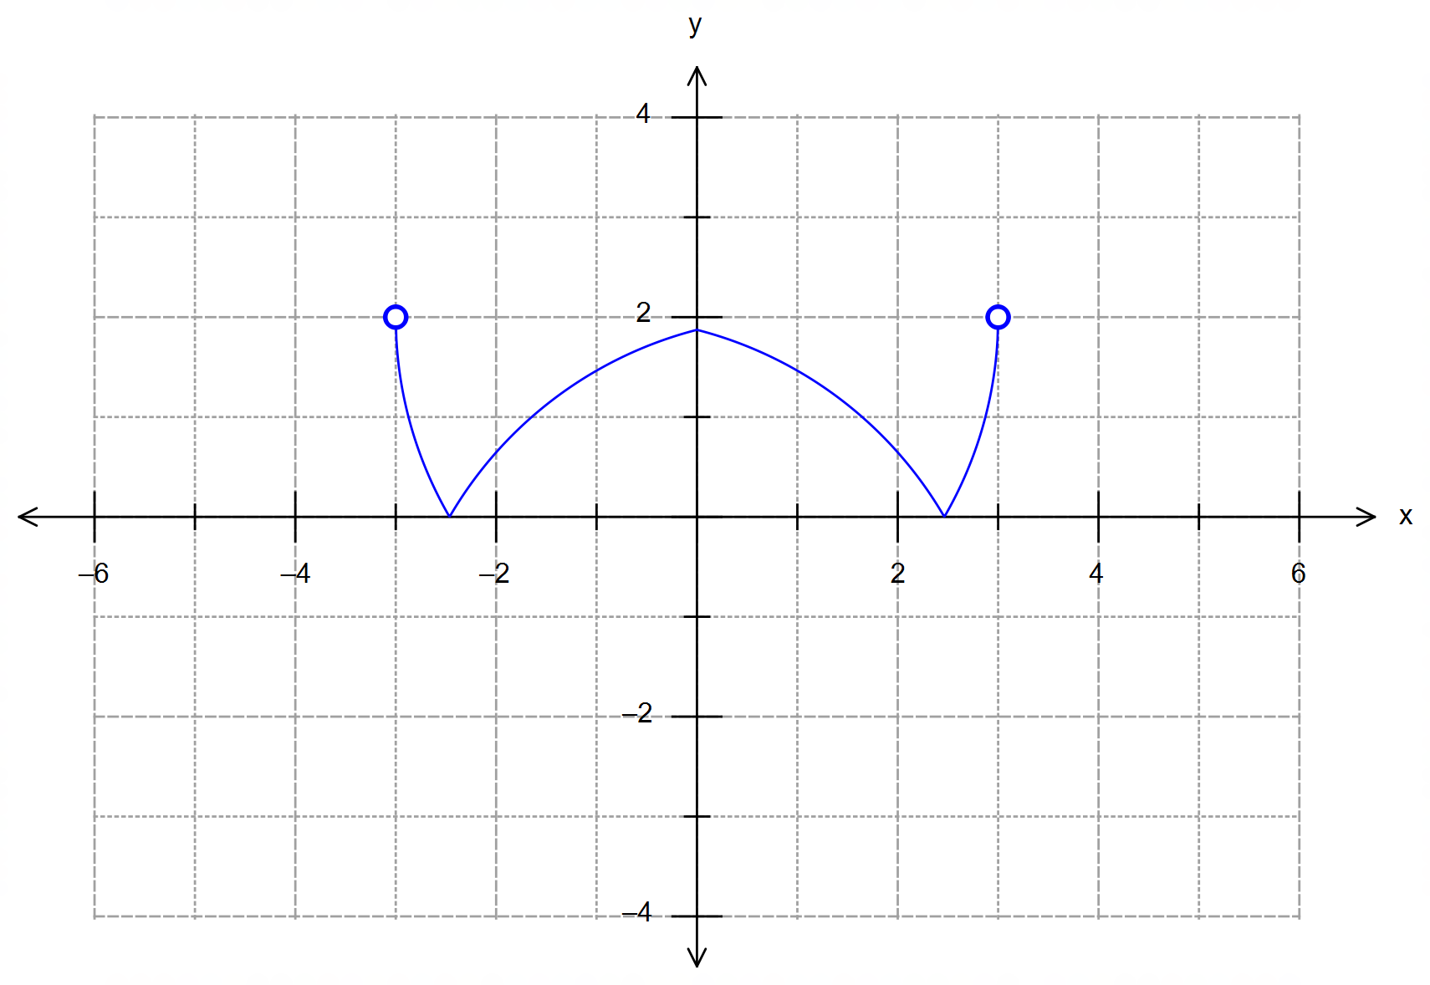17. (a) (i)

✓ reflection over x axis

✓ reflection over y axis

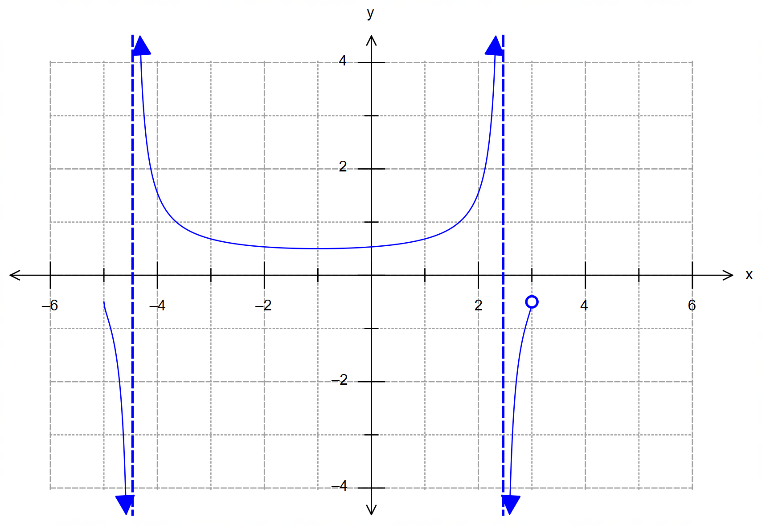17. (a) (ii)

✓ vertical asymptotes

at the roots of the circle

✓ crosses the original

function at points

✓ behaviour on either side

of the asymptotes

(b) (i) ✓

(ii) For :

✓

Domain of ✓

Range of ✓ [9]

18. (a) seconds ✓

(b)  [m] from O ✓

✓

[m/s] ✓

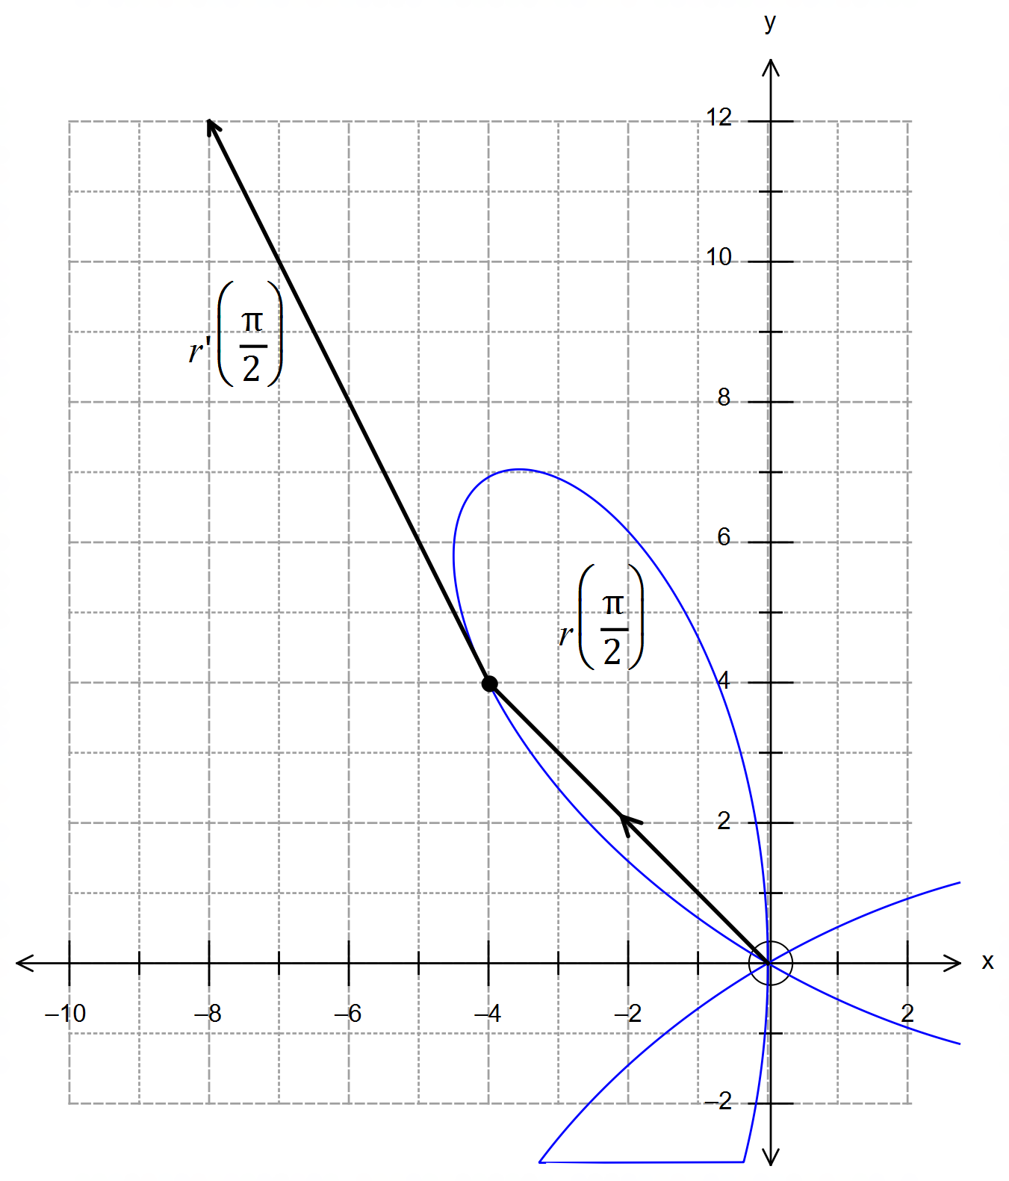18. (b) Continued.

✓ position vector (-4, 4)

drawn from O.

✓ velocity vector (-4, 8)

relative to (-4,4)

[i.e. drawn from (-4 ,4)]

(c) m/s ✓

for ✓

✓ [9]

19. (a) the apparent “root” is in fact a discontinuity which

occurs at ✓

✓

✓

(b)

✓✓ [9]